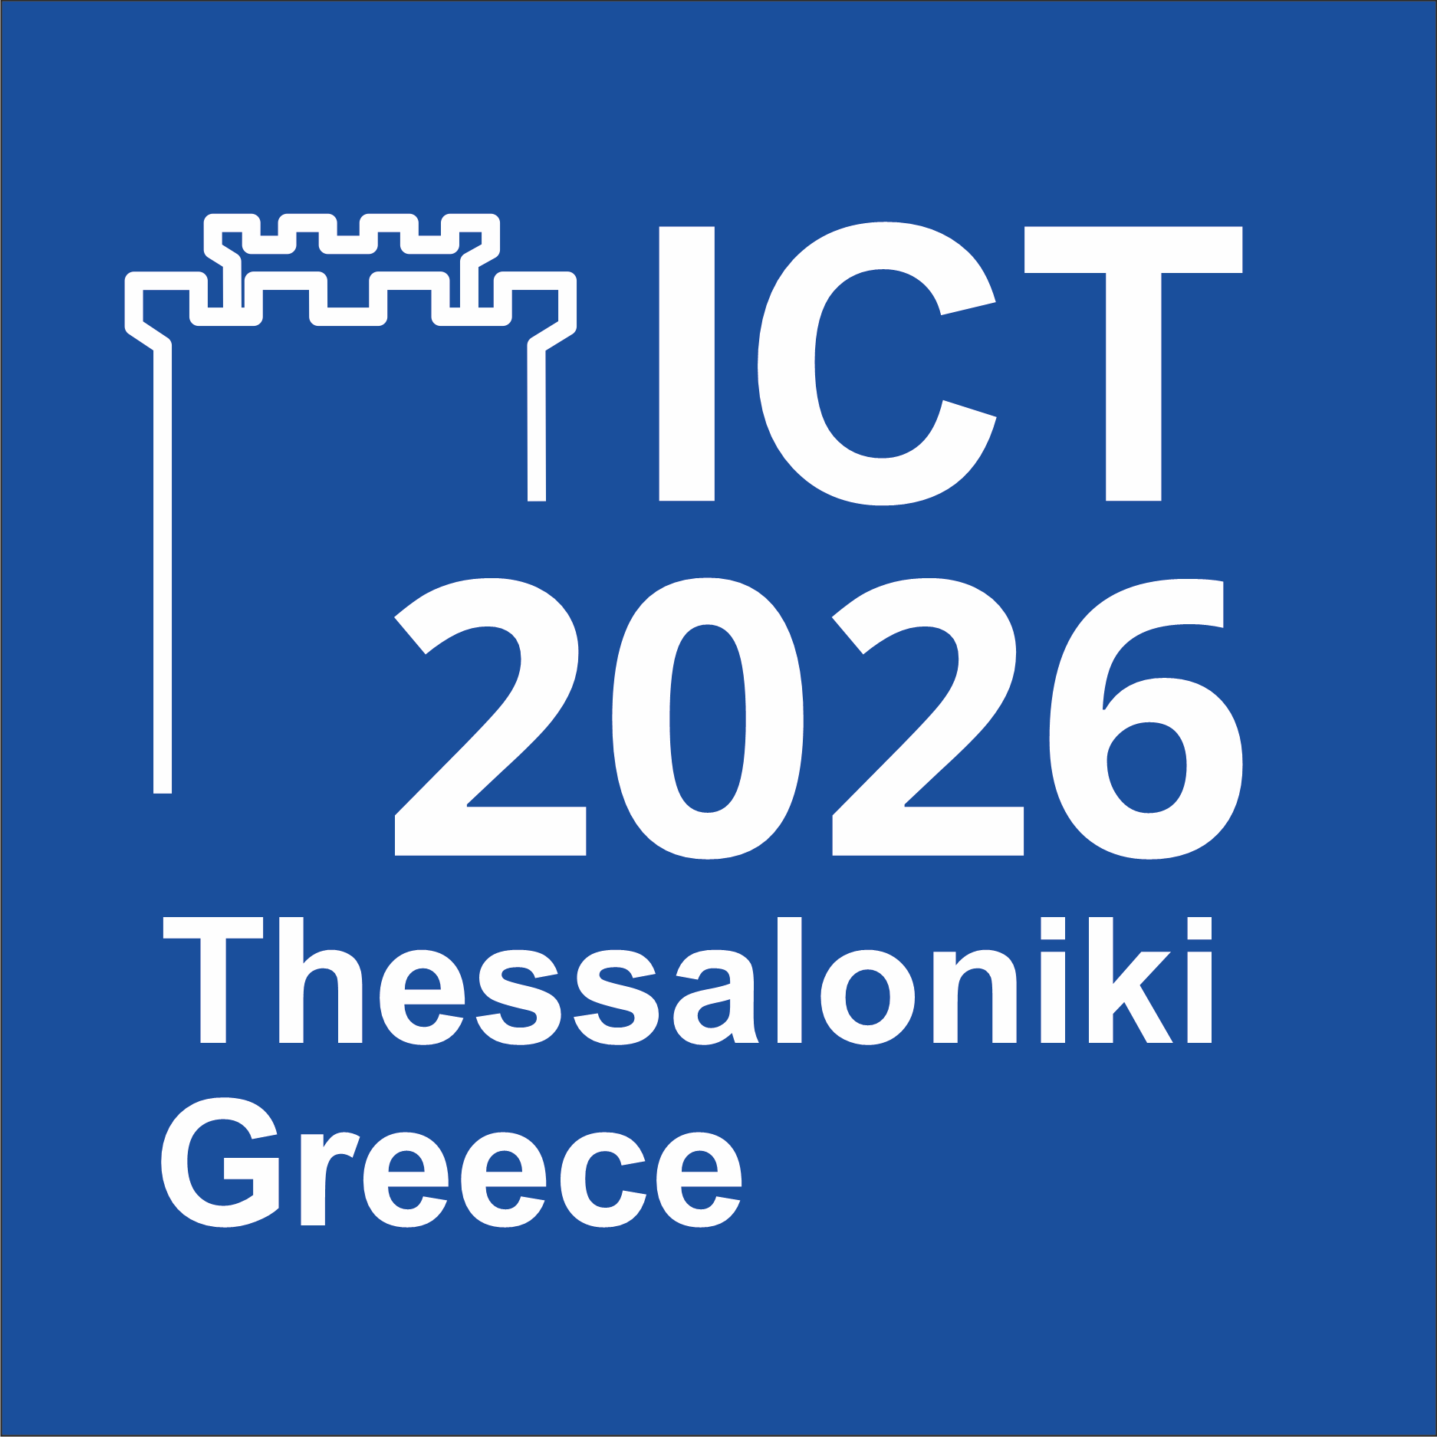

International Conference on Telecommunications (ICT)

20-22 May 2026, Thessaloniki, Greece

Workshop (Special Session) on “title to be completed”

Workshop (Special Session) co-Chairs:
Name, Affiliation – email address
Name, Affiliation – email address

Brief description (max. 1 page)
(provide an overview paragraph together with a list of topics of interest the Workshop/Special Session as well as reasons why and how the Workshop/Special Session would attract the ICT 2026 audience).

Technical Program Committee (TPC)
(at least 10 TPC members that will be invited)

Potential support
(by research projects and/or scientific organizations such IEEE/ACM Societies/Chapters and others)
History of the proposed Workshop/Special Session (if applicable)
(a description of the past events of the Workshop/Special Session, including website address, and statistics of submitted/accepted papers, maximum acceptance ratio and attendee numbers. Note that all papers will be peer-reviewed)

Short (150-200 words) bio of the co-Chairs
co-Chair 1
Short bio:

co-Chair 2
Short bio:

